**Ntuaflix2023-30**

**Software Requirements Specification**

Version 2

# Revision History

|  |  |  |  |
| --- | --- | --- | --- |
| Date | Version | Description | Author |
| 15/12/2023 | 1 | First Version of S.R.S. | Team |
| 18/02/2024 | 2 | Final Version of S.R.S. | Team |
|  |  |  |  |
|  |  |  |  |

# Table of Contents

Revision History 2

Table of Contents 3

Introduction 4

Purpose 4

Scope 4

Definition, Acronyms and Abbreviations 4

References 4

Overall Description 4

Problem Statement 4

Background 4

Objectives 4

Constraints 4

Functional Requirements 4

Use Cases 4

Requirements 5

User Requirements 5

Technical Requirements 5

Performance 5

Scalability 5

Security 5

Maintainability 5

Usability 5

Localization Support 5

Auditing and Logging 5

Availability 6

Hardware Requirements 6

Network 6

Client Computers 6

Deployment Requirements 6

Nodes 6

Components 6

Artifacts 6

Other Requirements 6

Appendices 6

# Introduction

This document provides a comprehensive architectural overview of Ntuaflix, outlining the system's intended capabilities, environment, and main functionalities. It aims to give stakeholders a clear understanding of the system requirements and serves as a guideline for the development team to design and implement the system. The focus is on the user requirements, system features, and the constraints under which the system must operate.

## Purpose

The purpose of this document is to clearly define the system to be developed, ensuring that the end user, designers, and developers have a thorough understanding of the requirements and functionalities of Ntuaflix. It serves as an agreement between stakeholders and the development team regarding the system's features and constraints.

## Scope

This document will cover the Ntuaflix system, focusing on its interaction with end users, the technical requirements for its development, and its operational environment. It will describe the stakeholders, the integration with existing systems, and the business processes that Ntuaflix aims to enhance or replace.

## Definition, Acronyms and Abbreviations

|  |  |
| --- | --- |
| Term | Definition |
| RAID | (Redundant Array of Independent Disks): A data storage virtualization technology that combines multiple physical disk drive components into one or more logical units for the purposes of data redundancy, performance improvement, or both. |

## References

No references used.

# Overall Description

## Problem Statement

End users currently face issues such as a limited selection of movies/shows, difficulties in navigating the existing system, and slow performance during peak usage times.

## Background

The problems identified stem from outdated system architecture, which cannot effectively handle current user demands and lacks modern features that facilitate user engagement. Additionally, slow performance issues have escalated due to an increase in the number of users, driven by changes in the business environment and new business policies aimed at expanding the user base.

## Objectives

Ntuaflix aims to provide a user-friendly platform for browsing, searching, and viewing movies and shows. It seeks to offer enhanced performance, a broad selection of content, and interactive features such as ratings and reviews, thereby addressing the current system's limitations.

## Constraints

The only constraint this project has is its poor scalability, as it can sustain up to 100 users simultaneously.

# Functional Requirements

Ntuaflix will include features such as advanced search capabilities, user authentication and profile management, movie/show ratings and reviews, personalized recommendations, and seamless integration with external services like IMDb for additional content information.

## Use Cases

### Use Case Diagram

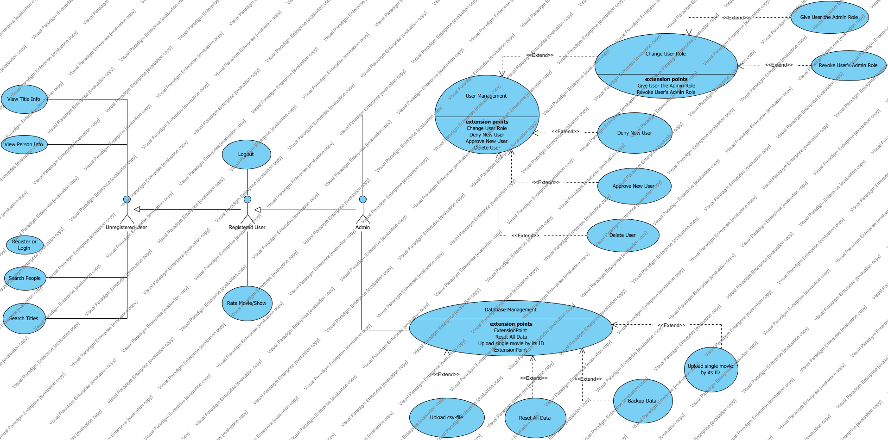

|  |  |
| --- | --- |
| Use Case | Description |
| Approve New User |  |
| Backup Data |  |
| Change User Role |  |
| Database Management |  |
| Delete User |  |
| Deny New User |  |
| Give User the Admin Role |  |
| Logout |  |
| Rate Movie/Show | They can rate the movie or show (not a single episode, but the show all over) in a grade from 1 to 10 stars. The average rating is updated accordingly. |
| Register or Login |  |
| Reset All Data |  |
| Revoke User's Admin Role |  |
| Search People | There're no filters for this type of search. |
| Search Titles | They can use certain filters: genre (one or multiple), rating range, year release range. They can also filter by searching only for movies or only for shows. |
| Upload csv-file | The csv upload options are: pload title basics, upload name basics, upload title akas, upload title crew, upload title episode, upload title principals, upload title ratings. |
| Upload single movie by its ID | We search the movie we want to upload from imdb. In the link, there's its id. For example, for Dune (2021): https://www.imdb.com/title/tt1160419/, so the id istt1160419. |
| User Management |  |
| View Person Info | 1) If the selected person has a photo, the user is able to press on that photo so to be redirected to the corresponding official IMDb site.  2) In the "Known for Titles" tab, the titles that are in a **golden box** represent the title that the person is **most known for**. |
| View Title Info |  |

## Requirements

|  |  |
| --- | --- |
| Requirement | Description |

# User Requirements

The intended users of Ntuaflix are movie and TV show enthusiasts ranging from casual viewers to cinephiles. The system is designed for use across various environments, including personal computers and mobile devices, ensuring accessibility and convenience for users at home or on-the-go.

|  |  |
| --- | --- |
| Actor | Description |
| Admin | Administrators are also registered users. |
| Registered User | The registered user has the capabilities of the unregistered user, as well as logging out and rating. |
| Unregistered User |  |

# Technical Requirements

## Performance

## Scalability

## Security

## Maintainability

## Usability

## Localization Support

## Auditing and Logging

## Availability

# Hardware Requirements

Ntuaflix requires a web server capable of running modern web technologies (e.g., HTML5, CSS3, JavaScript), a database server that supports SQL databases, and adequate storage and processing power to handle high user traffic and data throughput.

## Network

## Client Computers

# Deployment Requirements

## Deployment Diagram

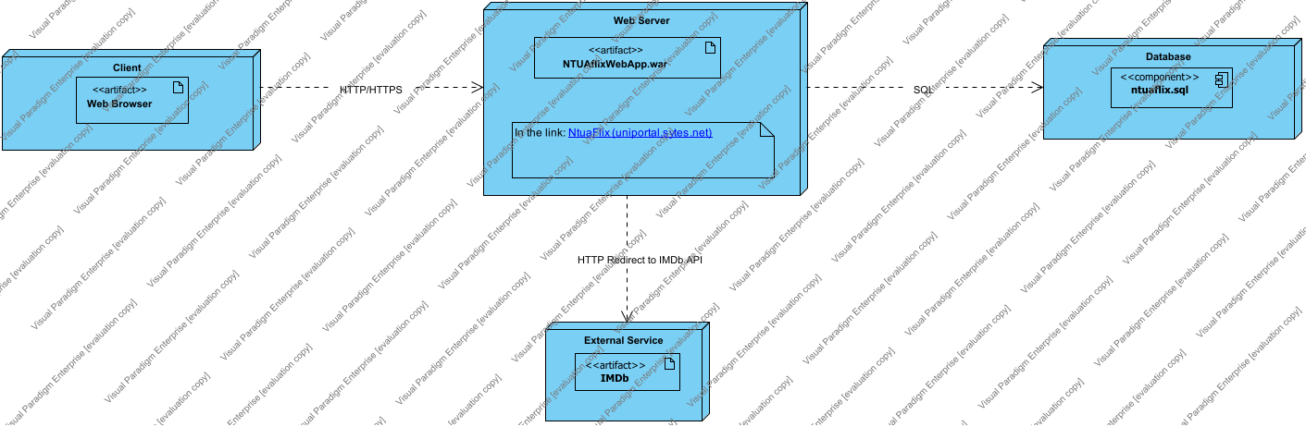

## Nodes

|  |  |
| --- | --- |
| Name | Description |
| Client | Represents the end-user devices such as smartphones, tablets, or computers through which users interact with the web application using a web browser. |
| Database |  |
| External Service | If the user clicks on one person's image, they'll be redirected to their corresponding IMDb profile tab. |
| Web Server | Acts as the intermediary between the client devices and the application server, handling HTTP/HTTPS requests and responses. |

## Components

|  |  |
| --- | --- |
| Name | Description |
| Admin Redirection | Determines redirection after login. |
| Authentication |  |
| Database |  |
| Database |  |
| Database |  |
| Database: People | 1. Maintains records of actors, directors, and other movie industry professionals. 2. Includes biographical data, filmography, and professional milestones. |
| Filter |  |
| IMDb Redirection |  |
| Login Interface |  |
| ntuaflix.sql |  |
| People Info |  |
| Search Controller |  |
| Search Controller |  |
| Session Management | Maintains user session state. |
| Title Info |  |
| Title Rating |  |
| User Interface |  |
| User Interface |  |
| User Intreface |  |
| User Role Management | Checks user roles. |

## Artifacts

|  |  |
| --- | --- |
| Name | Description |
| IMDb |  |
| NTUAflixWebApp.war | Serves as the front-end user interface of the service. Built to deliver a responsive and intuitive user experience across various devices and platforms. |
| Web Browser |  |

# Other Requirements

# Appendices